GroupBuild User Roles

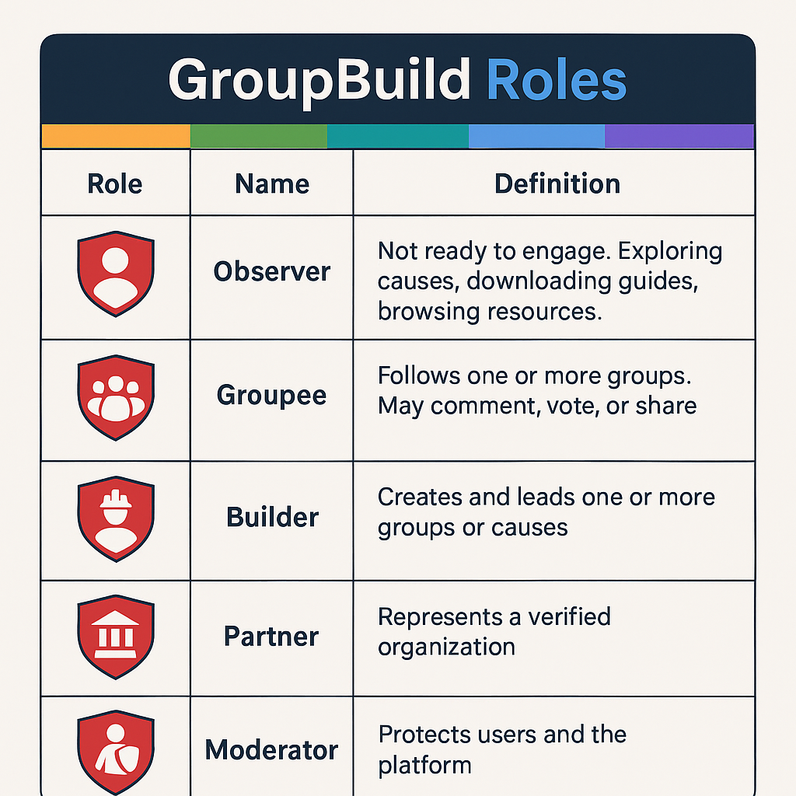
1. Purpose
This document defines the core user roles (GB_Role) within the GroupBuild (GB) platform. Each role represents a key user motivation and determines the presented functionality, UI exposure and access permissions. The registration process involves the site visitor selecting from a drop-down list of non-duplicate, randomized alpha-numerics, resulting in an AnonID in the format ID:xxxx. They then select their GB_Role, defaulted to Observer, from a second drop-down list, see Role Enumeration, section 2. GB_Role variables can thus be updated during user-registration, but they are also subject to revision based upon user behavior (e.g. creating a Group updates GB_Role to ”Builder”, or based upon manual assignment by user or Developer (includes Site Admin). All users may share content externally, or notify/message other users' external web-services, but if this is done using GB-integrated functionality, it must be anti-spam and one-click unsubscribe while ensuring the user remains anonymous to the GB web-service and to the user's share-recipients, (but given global Internet regulations, this may not prove to be feasible functionality).

2. Role Enumeration
GB_Role | Variable Name | Definition | Examples of Behavior | Transition Conditions
Observer | GB_Observer | Default role for new users. Passive exploration, resource downloads. | Browsing, downloading safety-tent guide, no group interactions. | Initial default state, no AnonID-login
Groupee | GB_Groupee | Actively follows Group(s). May comment, post content, vote, or share. | Joins existing groups, comments on posts, votes in polls. | Observer who joins or follows a group
Builder | GB_Builder | Creates or leads group(s). Access to group management tools. | Launches a campaign, posts updates, organizes events. | Groupee who creates a group
Partner | GB_Partner | Verified rep of org, media, civic body. Access to GB-branded tools. | Connects NGO, school, or org; uses licensed tools. | Observer/Groupee approved via verification flow
Moderator | GB_Moderator | Appointed by Site Admin or elected within Group(s). Protects only said Group(s) via moderation tools. | Approves posts, flags hate speech, manages disputes. | Manual assignment by admin or vote
Developer | GB_Developer | Volunteer technical contributor. Backend access and special controls. | Fixes bugs, pushes feature updates, reviews logs, reviews BeAxa's content warnings. | Manual assignment by project lead

3. Role-Based UI Behavior
Each GB_Role will dynamically configure key parts of the interface. The following UI blocks are role-dependent:
- Observer: Intro carousel, public resources, explore map, no posting tools.
- Groupee: Group follow feed, basic comment tools, participation prompts.
- Builder: Group admin dashboard, event scheduler, recruit tools, campaign media uploader.
- Partner: Org branding dashboard, verified status badge, BeAxa license tools.
- Moderator: AI moderation queue (BeAxa), user report logs, warning/ban tools.
- Developer: Debug mode panel, feature flag toggles, analytics access.

4. Role Transition Logic
Role transitions occur via either:
- Behavioral Triggers (e.g., a user creates a new Group so their GB_Role updates to Builder)
- Manual Approval (e.g., a user asks a Group Builder to approve their Group Moderator status, or a staff member verifies a user as a Partner)
- System Hooks should audit each transition and log timestamp, triggering UX refresh

5. Avatar Customization Policy
Avatars are always on a red shield background, but a set of customized avatars, and/or avatar-customization, may be unlocked based on trust level and GB_Role:
- Observers: A single default avatar preset, e.g. a BeAxa-kitten eye on a red shield.
- Groupees & Builders: Tiered customization with safety review (e.g. can't upload a swastika)
- Partners: Branded avatars allowed, typically custom-made, by staff for Partner
- Group-specific Moderators: Embellished version of Group's avatar, which is the same as the Builder's avatar
- Site-wide Moderators & Developers: Each given a fixed avatar, e.g. site-wide Moderator could use a GB_Mod avatar versus the Group-specific Moderator's G-Mod avatar.
Avatar uploads should be clear-background .png images that will show up over a red-shield background. All such uploads should be pre-checked by BeAxa, with a fallback to human moderation if there are significant concerns.

6. Badging and Sub-Roles (Optional Extensions)
To avoid GB_Role inflation, additional user role states may be stored as badges, not new roles. These badges should influence both UI-affordances and backend trust scoring. For example:
- maker – for trusted content creators, especially those authorized to post content on our resource page or anti-censorship library.
- donor – for financial contributors, or Partners who provide significant advisory contributions
- verified – for authenticated identity

